STAAD Engineers Ltd.

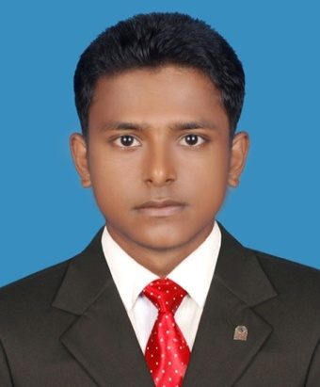
KEY PERSONNEL

Md. Mahade Hasan

Structural Detailer

Diploma in Civil Engineering.

E-mail: mhkzero.bd@gmail.com

Cell: +88 01991-680590

Work Undertaken that Best Illustrates Capability to Handle the Tasks Assigned

❖ Ten storied factory building with one basement in Ashulia, Savar, Dhaka.
❖ Ten storied commercial cum residential building in Demra, Dhaka
❖ Nine storied residentil building in Mohammadpur, Dhaka.
❖ Eight storied apartment building in Mirpur-1, Dhaka.
❖ Five storied residential building at Moksedpur, Gopalganj.
❖ Five storied residential building in Bogura.
❖ Four storied residential building in Sreepur, Magura.
❖ Three storid madrasa building in kishoreganj.
❖ Triplex building in Keranigong, Dhaka.
❖ Two storied generator building in Gazipur.
❖ Duplex building in Tangail.
❖ Single storied residential building in Magura.
❖ Single storied residential building in Bhola.
❖ Single storied industrial steel shed in Tongi, Gazipur.
❖ Single storied steel factory shed in Gazipur.
❖ Two storied industrial building (production shed-1) in Mymensingh.
❖ DEA of Four storied factory building for Newage Textiles Limited.
❖ DEA of Four storied factory building for Denim Plus (BD.) Ltd. in Chittagong.
❖ DEA of Single storied canteen shed for Denim Plus (BD.) Ltd. in Chittagong.
❖ DEA of Single storied boiler and genarator shed (Mega Washing & Dyeing Ltd.) in Gazipur.
❖ DEA of Five storied factory building for Liz Fashion Industry Ltd. in Gazipur.
❖ DEA of Four storied factory building for New Horizon (BD.) Ltd. in Savar, Dhaka.
❖ DEA of Single storied dyeing factory building for Opex & Sinha Group in Narayangonj, Dhaka.
❖ DEA of Single storied garments factory shade for Wisteria Textiles Ltd. in Sreepur, Gazipur.
❖ DEA of Single storied dyeing factory shade for Wisteria Textiles Ltd. in Sreepur, Gazipur.
❖ DEA of Single storied knitting factory shade for Wisteria Textiles Ltd. in Sreepur, Gazipur.

Highlights
❖ 3 years of Structural Detailer Experience.
❖ Possesses Construction Knowledge.
❖ Applicable knowledge in Microsoft project, AutoCAD, Revit Architecture etc.
❖ Strong inter-personal skills.

Experienced in

❖ Working with in-house.
❖ Business development.
❖ Preparing construction documents.
❖ Real Estate feasibility.

